**Bellabeat FitBit Case Study**

**INTRODUCTION:**

Bellabeat is a high-tech manufacturer of health-focused products for women. The cofounder and Chief Creative Officer of Bellabeat, believes that analysing smart device fitness data could help unlock new growth opportunities for the company.

**PROBLEM STATEMENT:**

To identify potential opportunities for growth and recommend ideologies to improve the marketing strategy of the company based on the trends in the smart device usage.

**DATA SET USED:** The data about the user's sleep, activity, calories burnt and sedentary time was gathered as a part of the certification program along with the problem statement.

**TOOL USED:** R Programming Language for data analysis and visualizations.

**DATA PREPARATION & PROCESSING:**

- The data set was checked for any NULL or missing values in excel sheets and then imported into R Studio and formatted to proper date and time formats.

- For analysis, the data sets were combined to make proper data visualizations.

**DATA ANALYSIS AND VISUALIZATIONS:**

- The summary statistics of the data sets were found and the following discoveries were obtained from the summary as follows:

1. A positive correlation is seen between the total steps and the calories burnt by the users as follows

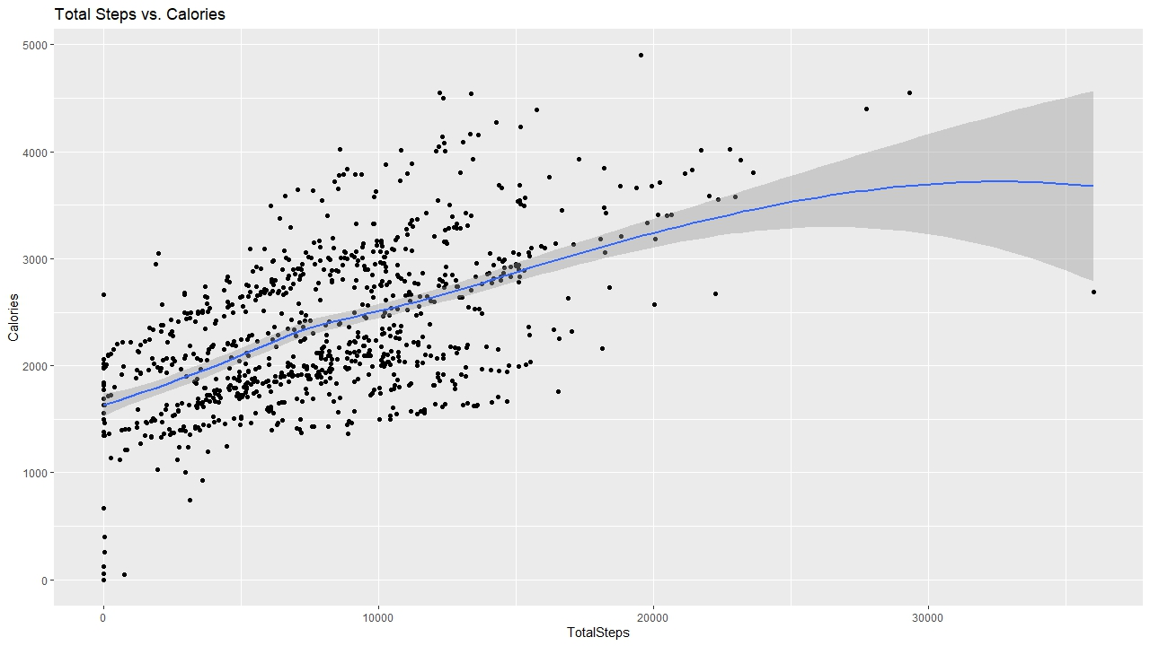

2. Active hours - 5pm to 7pm which can be seen below

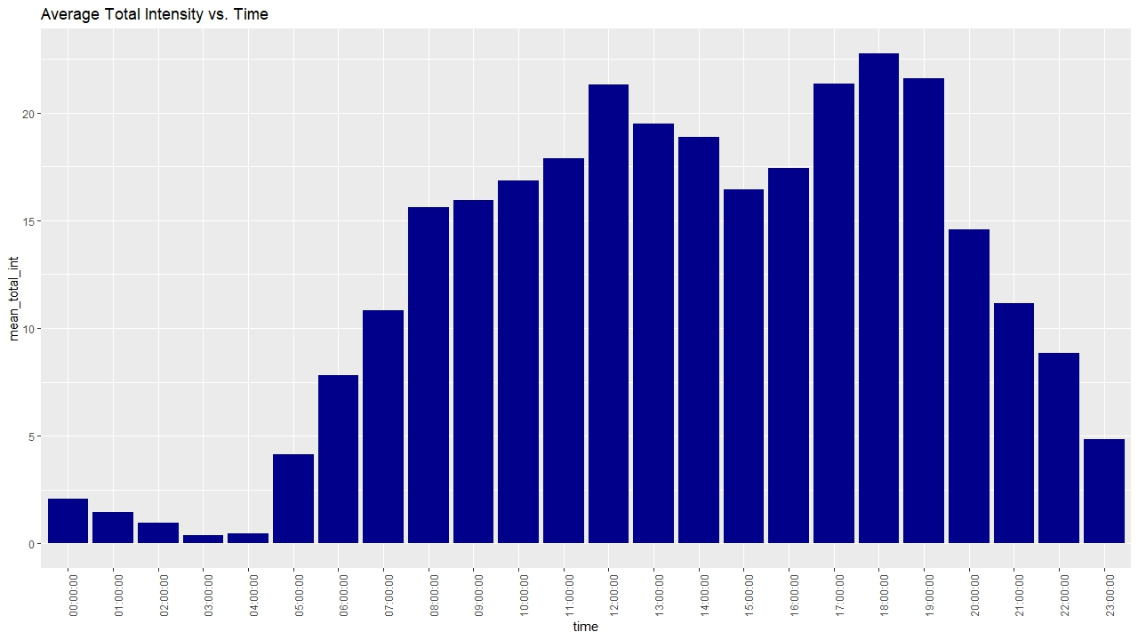

3. A negative correlation is seen between Sedentary time and Sleep time as follows

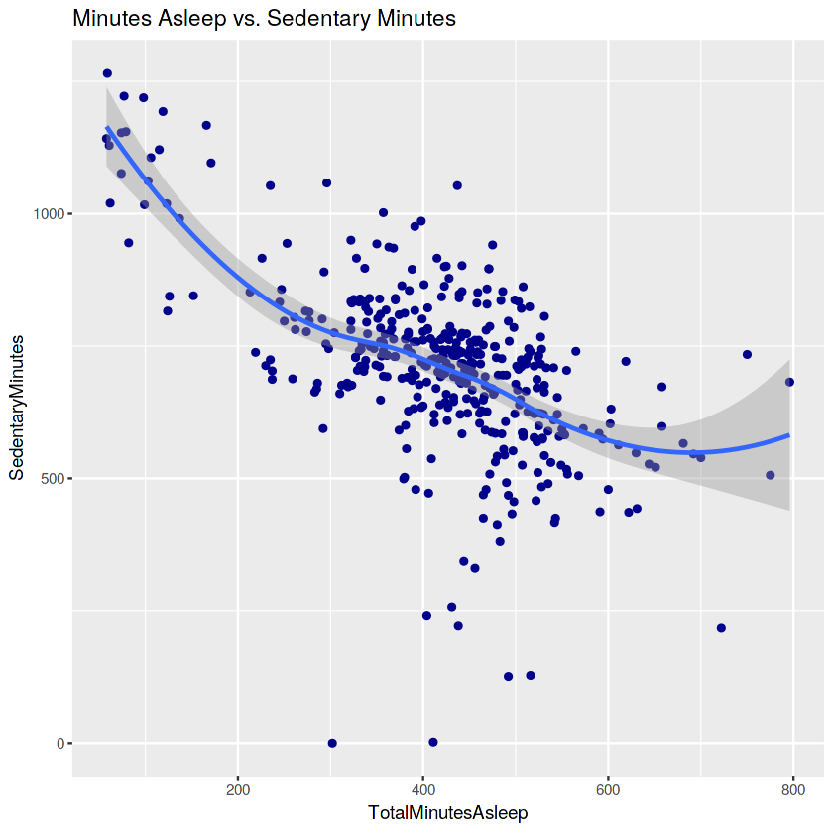

**KEY INSIGHTS & SUGGESTIONS:**

1. Since from the summary it is seen that the Average Total Steps by the users are less than 8000, a notification can be sent to the users to encourage them to walk more stating its benefits for a good health.

2. Since the most activity is happening between 5pm-7pm, a notification to remind the users to go for a walk or run will be useful.

3. Average Sedentary time is more which is unhealthy, so a notification to stay active and reduce the sedentary time will also be helpful to monitor their activities.

4. Fitbit does not have information about user hydration level, so bellabeat can try to incorporate this information as well since staying hydrated is also a key factor for a healthy lifestyle.